Parth Babbar

online banking services

Introduction:
Online banking has changed the way people in the United States handle their finances. Financial institutions embrace digital technology and provide a variety of online services that improve convenience, efficiency, and accessibility. Online banking, often known as internet or online banking, allows clients to monitor account balances, transfer payments, pay bills, and manage accounts without having to visit a real bank office.
Key Features:
- Account Management: Customers may see their account balances, transaction history, and download account statements.
- Funds Transfer: The capacity to move money between accounts within the same bank and across banks, including interbank transactions.
- Bill Payment: Customers may set up and pay regular bills, such as utility and credit card bills, online.
- Mobile Deposits: Deposit checks utilising a smartphone camera and online banking systems.
- Loan Applications: You may apply for personal loans, mortgages, and other credit products online.
- Investment Services: Manage investment accounts, purchase and sell assets, and obtain financial advice.
- Customer Service: Contact help via chat, email, or secure messaging.
Benefits:
- Convenience: Customers may access their accounts and do transactions from any location with an internet connection, at any time.
- Efficiency: Online banking reduces the need for real bank visits, allowing for rapid and uncomplicated financial management.
- Cost Savings: Reducing reliance on paper statements and in-person services allows banks to save operational expenses while also providing free or low-cost services to clients.
- Real-Time Monitoring: With instant access to account information, users can keep track of their funds in real time.
- Enhanced Security: Multi-factor authentication, encryption, and other security measures prevent fraud and unauthorised access.
Challenges:
- Cybersecurity Risks: Online banking systems are prone to hacking, phishing, and other cyber threats, which increase the risk of cyber-attacks and fraud.
- Technical Issues: Downtime, software difficulties, and network issues can all impede access to online banking services.
- Digital Divide: Not all clients have access to the internet or feel comfortable utilising digital banking services.
- Privacy Concerns: Customers may be concerned about the privacy of their financial information and data security.
Solutions:
- Improved Security: To reduce cybersecurity threats, banks are investing in sophisticated security technologies such as biometric identification, encryption, and AI-powered fraud detection.
- Technical assistance and Infrastructure Upgrades: Financial institutions are improving their IT infrastructure and providing strong technical assistance in order to handle technological difficulties as quickly as possible.
- Bridging the Digital Divide: Banks are providing education and tools to assist less tech-savvy consumers in accessing and using online banking services. They are also aiming to increase internet connectivity in underserved communities.
- Enhanced Privacy Protections: Enforcing stringent data protection regulations and clear privacy procedures to allay client concerns regarding their financial information.
Banking Providers:
- Chase Bank: Provides a complete online banking platform with sophisticated mobile app functionality.
- Bank of America: Recognised for its user-friendly online banking interface and diverse variety of services.
- Wells Fargo: Offers a wide range of online banking services, such as mobile deposits and bill payments.
- Citi Bank: Provides excellent online banking facilities and robust security safeguards.
- Ally Bank: This online-only bank offers attractive interest rates and fee-free banking services.
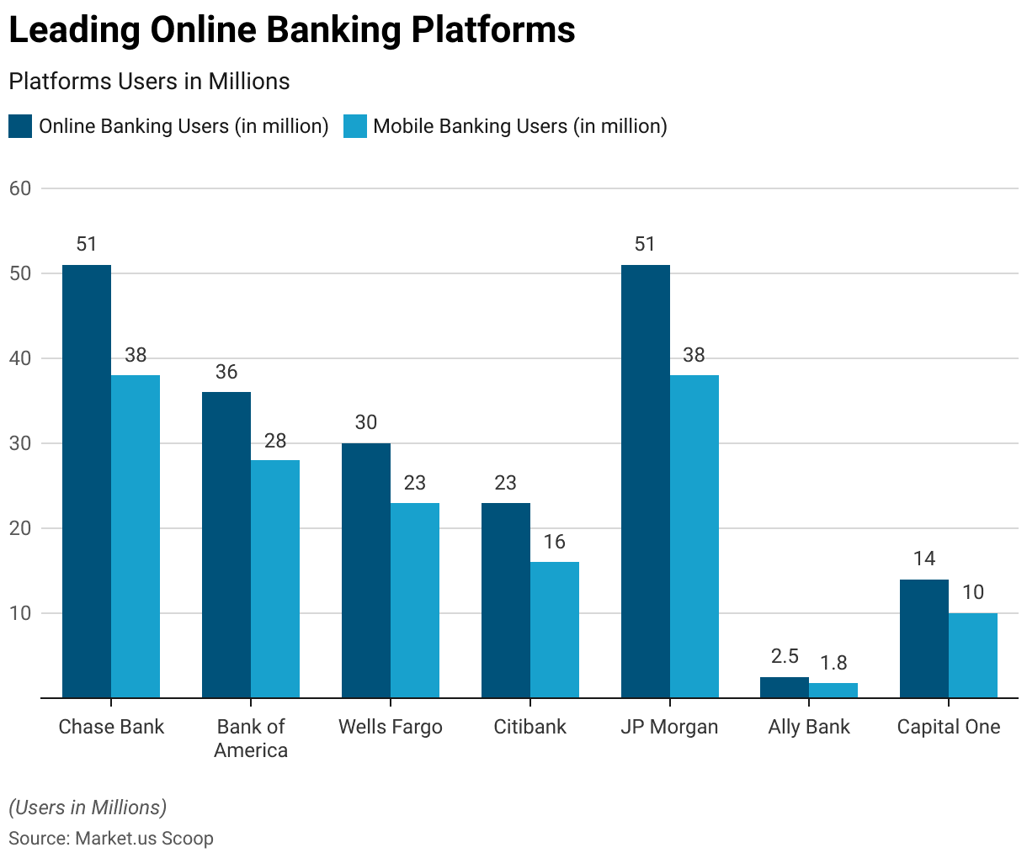
Future Trends:
- Enhanced Security Measures: Biometric authentication, AI-powered fraud detection, and blockchain technology will all be implemented.
- Personalized Services: The use of data analytics and artificial intelligence to provide individualised financial advise and services.
- Integration with Fintech: Banks and fintech companies collaborate to develop innovative products.
- Expansion of Digital Wallets: The rise of systems such as Apple Pay, Google Wallet, and PayPal.
- Sustainability Initiatives: Implementing eco-friendly practices and paperless banking.
- Voice and Chatbot Banking: Using voice assistants and chatbots to connect with customers.
- Open financial: Using open APIs to better financial services.
Statistics:
- As of 2023, around 80% of US adults utilise internet banking services.
- Younger generations, notably Millennials and Generation Z, are the most active consumers of internet banking.
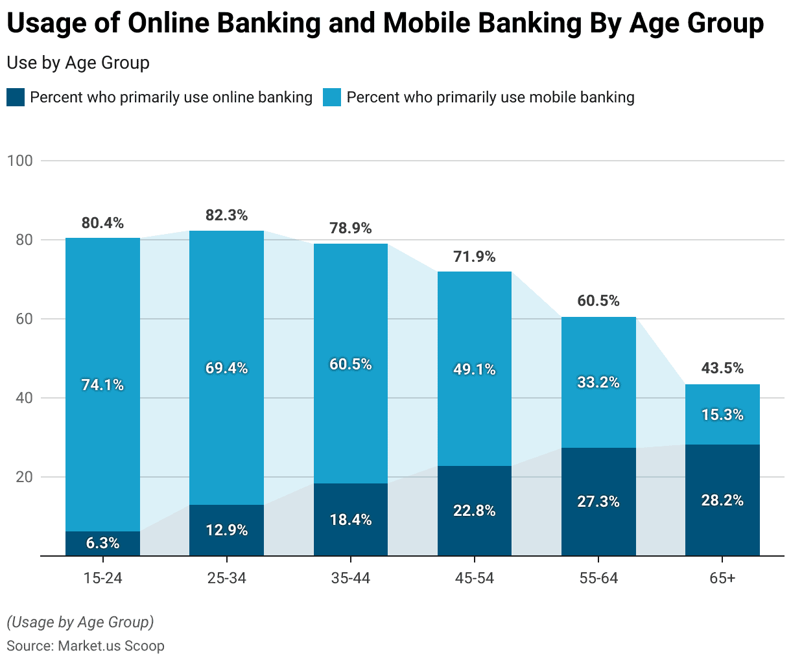
- According to surveys, around 85% of online banking consumers are very satisfied with their digital banking experience.
- Approximately 60% of consumers are concerned about the security of their online banking information.
Conclusion:
Online banking is essential to the US financial environment, helping both customers and institutions. Despite issues such as cybersecurity and digital access limitations, continued technological improvements indicate a brighter banking future. As use increases, internet banking affects US financial services, adapting to meet client demands for safe, convenient, and efficient banking.

